DATA TRANSFER FROM SENSOR TO IBM CLOUD

* IBM Cloud data Storage

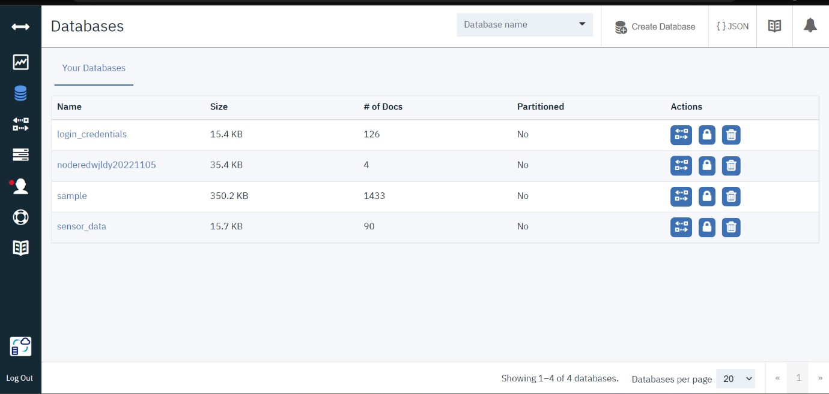

* User Login Data Storage

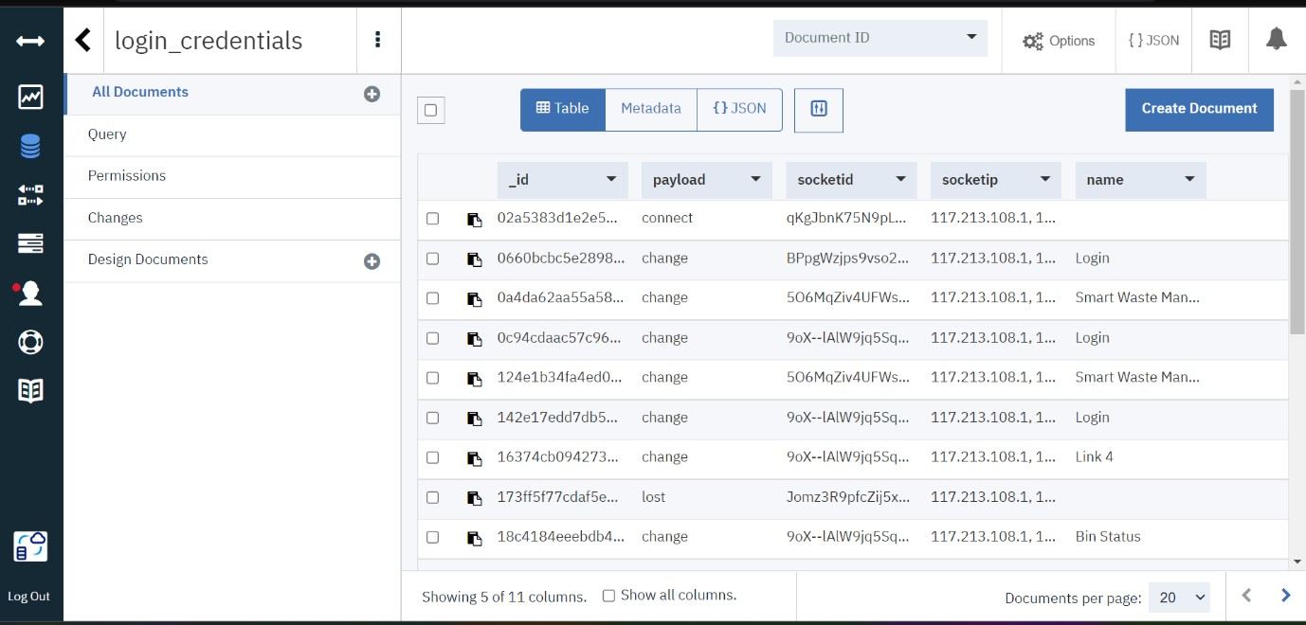

* JSON Format of Data Storage

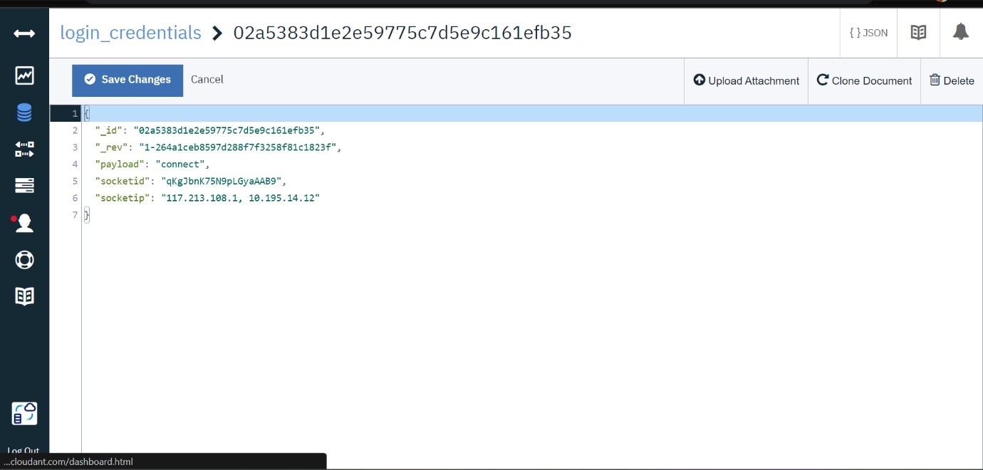

* Data transmission of sensor from bin

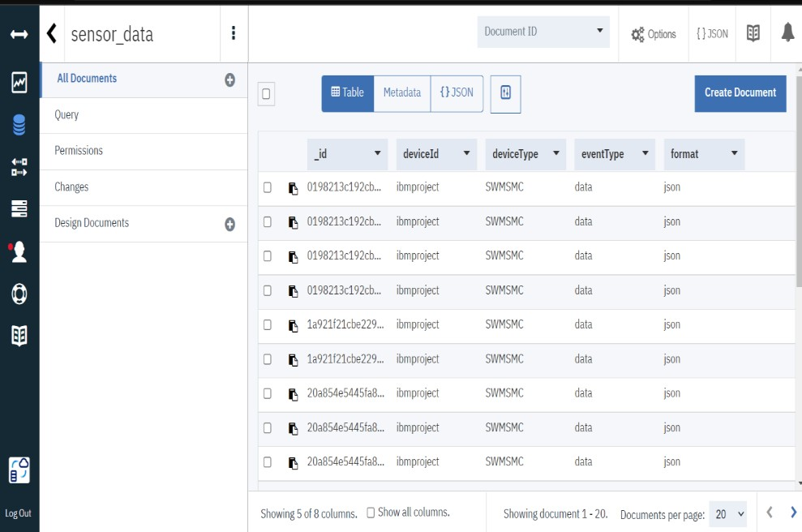

* JSON Format of Data Storage

